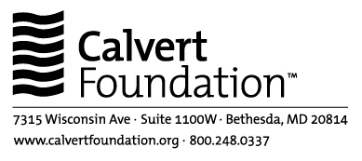

November 18, 2009

Terrence Ward
15 Gramercy Park
New York, NY 10003

Dear Mr. Ward,

We want to thank you for your letter dated November 9, 2009. We acknowledge that you have serious concerns about the operations of Lift Above Poverty Organization (LAPO) in Nigeria.

We want to re-assure you that our investment in LAPO was made following our standard operating procedures which include a comprehensive on-site due diligence evaluation that identified many of the issues you highlighted in your letter.

Acknowledging several important operating weaknesses, we have joined with LAPO’s other creditors to establish a Creditor Taskforce to advocate for internal reform in the areas of information management and transparency, financial management, governance, external audit, loan product pricing, and regulatory status. It is our belief that using our status as creditors to advocate for internal reform and improvements is preferable to taking more drastic action which might endanger the institution and, therefore, threaten access to critical financial services for thousands of poor Nigerians.

LAPO’s senior management has made several material improvements to their operations in response to the requests of the Creditor Taskforce, and have also made commitments in writing to make additional changes before year-end. In addition, management has committed to securing a new external rating to document these improvements and increase confidence in the institution. We provide more detail on these management commitments throughout the remainder of this letter.

Our plan is to wait for the results of the new external rating to verify that the desired operating improvements have indeed been made and are generating the intended outcomes. If the rating concludes that the required steps have not been taken and that operating weaknesses in these areas persist, we will then evaluate our options to take further corrective actions through our standard rights as a lender.

Below we address some of the more serious claims you make in your letter:

Legality of Savings Operations. We sought an opinion from local legal counsel as to the status of LAPO’s savings operations. Our counsel concluded that LAPO was operating in compliance with the “Microfinance Policy, Regulatory, and Supervisory Framework for Nigeria” issued by the Central Bank of Nigeria in December 2005. These guidelines allow for the mobilization of savings from clients of the institution.

Our due diligence evaluation noted that, while legal, the collection and management of savings without a banking license does not conform with best practice. Therefore, as mentioned above, we have been working with the Creditor Taskforce to encourage the transformation of LAPO into a depository institution regulated by the Central Bank as soon as possible. LAPO has received initial approval by the Central Bank for their application to transform into a “Microfinance Bank.” Their goal is to secure the banking license by year-end 2009.

Pricing of Loan Products. Our due diligence evaluation also identified the fact that LAPO’s effective interest rates on its loan products were quite high. Our analyst noted that these rates do tend to be lower than LAPO’s few formal and informal competitors. As with other issues, the Creditor Taskforce has advocated with LAPO for a lowering of interest rates. The management and board recently approved an across the board decrease which will be implemented by year end. We believe that the decrease in interest rates, in conjunction with other operating improvements that LAPO is making in advance of transformation into a bank, will result in better client service and orientation. We concur that LAPO has room for improvement in this area.

In the coming year, in conjunction with the Center for Financial Inclusion’s Campaign for Client Protection, Calvert Foundation will begin to collect more detailed data on each of our client’s practices in the areas of preventing over-indebtedness, transparent pricing, collections practices, staff behavior, redress of grievances, and privacy of data. We will use this process as an opportunity to encourage improvements in policies and procedures in each of these areas with LAPO and other borrowers.

Calvert Community Investment Note Prospectus. You reference in your letter the CCI Note Prospectus and the fact that Calvert Foundation’s clients are “predominantly non-profit borrowers.” In this instance the term non-profit reflects a legal status (e.g. not owned for the benefit of private inurement) rather than the profitability generated through operations. Non-profit organizations are not prohibited from generating a profit – they are simply not able to distribute these profits to owners. LAPO has been retaining profits earned in order to internally fund net worth required for a formal banking license. This is not an uncommon strategy among MFIs, but one that we do not find advisable given the undue hardship to borrowers that you so amply document.

In any case, while Calvert Foundation’s borrowers are predominantly organized as non-profits, our policies and guidelines do not prohibit us from investing in for-profit organizations. To the contrary, we believe that for-profit companies serving people at the bottom of the pyramid can produce significant social value, given the right management, vision, and operating model.

We thank you for your feedback as an investor in Calvert Foundation. In the case of LAPO, as with other microfinance clients, we are committed to working for needed improvements in our role as a lender and taking corrective actions when and where necessary. We take our role as an investor and manager of retail capital extremely seriously.

Sincerely,

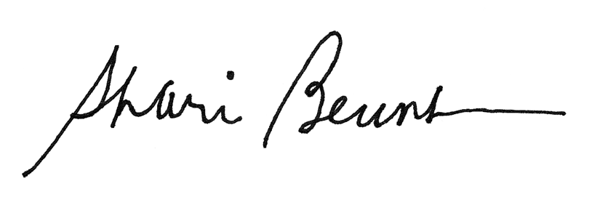

Shari Berenbach
President & CEO

