Lotus Notes and Blackberry users, please use the below link for full functionality:  
Blackberry version

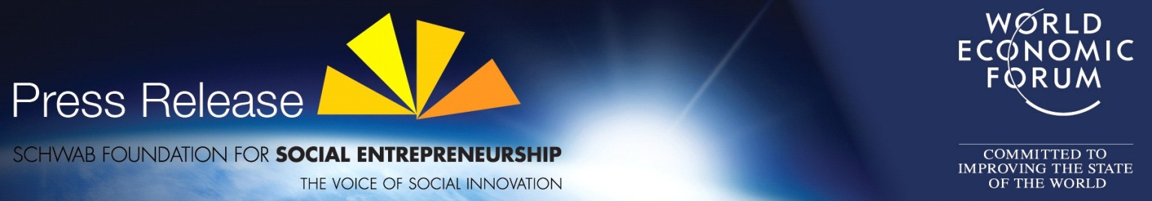

Richard Elliott, Associate Director, Communications Dept., Tel.: +255 (0)76 711 7715, E-mail: [richard.elliott@weforum.org](mailto:richard.elliott@weforum.org)

**AFRICA SOCIAL ENTREPRENEURS AWARDED IN DAR ES SALAAM, TANZANIA**

* Schwab Foundation announces the winners of the Africa Social Entrepreneurs 2010 Award ahead of the World Economic Forum on Africa, Dar es Salaam, Tanzania 5-7 May 2010
* Award will be presented during the Opening Plenary in the presence of President Kikwete of Tanzania
* Nigerian, South African and Tanzanian winners among group of leading social entrepreneurs who provide insights on sustainability and social innovation to the meeting’s theme
* Learn more about the Schwab Foundation at [www.schwabfound.org](http://www.schwabfound.org)
* Learn more about the programme of the World Economic Forum on Africa at [www.weforum.org/africa](http://www.weforum.org/africa)

**Dar es Salaam, Tanzania, 5 May 2010 –** Five social entrepreneurs have been recognized as Social Entrepreneur of the Year 2010 in Africa during the Opening Plenary session of the 20th World Economic Forum on Africa, in Dar es Salaam, Tanzania, on 5 May. Shona Mc Donald, founder of Shonaquip had previously been recognized as the Social Entrepreneur for South Africa. The other four winners are Godwin Ehigiamusoe of LAPO in Nigeria, Brien Holden and Kovin Naidoo of ICEE, and Victoria Kisyombe of SELFINA in Tanzania. They received their awards in the presence of President Jakaya M. Kikwete of Tanzania and the Co-Chairs of the 2010 World Economic Forum on Africa.

Social entrepreneurs emphasize long-term sustainability instead of short-term gains. Their primary focus is to maximize benefits for society and the environment by implementing innovative approaches to key challenges. They operate social businesses or organizations that are a mixture of non-profits and for-profits in areas such as energy efficiency, education, waste management, health, education, youth and rural development.

The winners will join a [group of leading social entrepreneurs](http://www.weforum.org/pdf/schwabfound/SocialEntrepreneurs_ForumAfrica2010.pdf) from across the African continent as well as others from Europe, India and the USA, and will be active participants providing insights on sustainability and social innovation in the discussions under the meeting’s theme *Rethinking Africa’s Growth Strategy*.

The Schwab Foundation for Social Entrepreneurship, an affiliate organization of the World Economic Forum, conducts the search and selection of social entrepreneurs in Latin America, Africa, the Middle East, India and South-East Asia. It selects three to five social entrepreneurs per year from each region. Selected social entrepreneurs are connected to the world’s business, political and media leaders through the events and initiatives of the World Economic Forum.

The following winners were awarded Social Entrepreneur of the Year 2010 in Africa.

|  |  |  |
| --- | --- | --- |
| **Godwin Ehigiamusoe**  **Lift Above Poverty Organization (LAPO)** | **http://www.lapogroup.org/** | **Nigeria** |

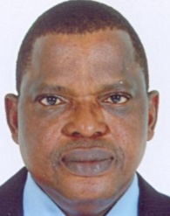

LAPO is the leading microfinance institution in Nigeria with over 240,000 clients. It is recognized for delivering sound financial and social services to alleviate poverty and empowering the disadvantaged. Alongside its financial services offering, LAPO supports enterprise development in diverse areas such as food processing, craftworks, merchandising, fabrication and farming, while the LAPO Development Foundation provides social and health empowerment programmes addressing issues of empowerment, nutrition, health, discrimination, injustice and gender equality.

|  |  |  |
| --- | --- | --- |
| **Brien Holden and Kovin Naidoo**  **International Centre for Eyecare Education** | **www.icee.org** | **South Africa and Australia** |

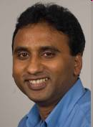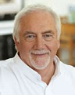

At least 670 million people, mostly in the developing world, are blind or vision impaired simply because they do not have access to a basic eye examination and a pair of glasses. ICEE works in ten African countries in addition to operations in Asia and Latin America to provide screening services and glasses prescriptions through its “Vision Centres”. It focuses on capacity building in the public sector to deliver eye care services, stimulating the professional role of optometrists and eye care providers, thereby expanding and sustaining its impact to 290,000 beneficiaries. It has also developed its own global supply chain and resource centre to reduce the cost of spectacles dramatically for its own services, and also for NGOs and public providers.

|  |  |  |
| --- | --- | --- |
| **Victoria Kisyombe**  **Sero Lease and Finance Association (SELFINA)**  **and Sero Businesswomen’s Association (SEBA)** | **www.serolease.com** | **Tanzania** |

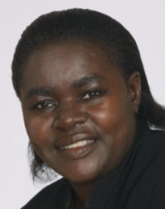

In Tanzania, where 75% of the population live in rural areas, and 33% live below the poverty line, most enterprising individuals do not have scarce working capital to buy equipment upfront. Victoria Kisyombe recognized that the capital outlay to buy assets and equipment for small businesses is difficult even on a microfinance loan and thus pioneered the leasing of fixed assets to women, which has led to the development of more than 18,000 value-added businesses and wealth creation. SELFINA’s clients, 60% of whom are in rural areas, become eventual owners of leased equipment and can use it as collateral for further borrowing.

|  |  |  |
| --- | --- | --- |
| **Shona Mc Donald**  **Shonaquip** | **www.shonaquip.co.za** | **South Africa** |

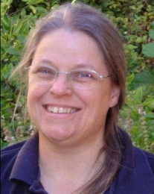

Shonaquip is a social business that provides high-impact support services that promote inclusion and equal opportunity employment for persons with disabilities. It promotes and supports the safe provision of appropriate wheelchairs, offering professional support services and clinical training for professionals and families. It also designs and builds Africa-appropriate wheelchairs and postural support devices suitable for use in rural, rough terrain and remote areas. Shonaquip have 40,000 clients (80% children) who have been provided with mobility devices and receive ongoing holistic postural support.

To view a PDF version of the Schwab Foundation Winners’ descriptions, please visit the following link:  
<http://www.weforum.org/pdf/schwabfound/seoy/SEOY_winners_AFRICA2010.pdf>

To view descriptions of all Schwab Foundation Social Entrepreneurs present at the meeting, please visit the following link:   
<http://www.weforum.org/pdf/schwabfound/SocialEntrepreneurs_ForumAfrica2010.pdf>

**Notes to Editors**

More information about the **Schwab Foundation for Social Entrepreneurship** at <http://www.schwabfound.org>

More information about the **World Economic Forum on Africa 2010** at <http://www.weforum.org/africa2010>

Join the **Davos Debates** at <http://www.youtube.com/davos>

Sessions and press conferences will be streamed live on **Livestream** at (<http://livestream.com/worldeconomicforum>).

**Photos** from the previous meeting at <http://www.weforum.org/africa2009>

Connect with the Forum on other social networks at <http://www.weforum.org/socialmedia>

Key quotes during the meeting on **Twitter** at <http://twitter.com/davos>

**Follow** the tweeps participating in the meeting at http://twitter.com/davos/wefafrica

Twitter users: Please use the hashtag **#WEF** for all tweets about the event

**Press Releases** at <http://www.weforum.org/pressreleases>

For updates about the activities of the World Economic Forum, subscribe to [RSS feed](http://www.weforum.org/en/rss/home/home.xml) [http://asia.cnet.com/2007/i/pf/ico_rss.gif](http://www.weforum.org/en/rss/home/home.xml)

The World Economic Forum is an independent international organization committed to improving the state of the world by engaging leaders in partnerships to shape global, regional and industry agendas.

Incorporated as a foundation in 1971, and headquartered in Geneva, Switzerland, the World Economic Forum is impartial and not-for-profit; it is tied to no political, partisan or national interests (<http://www.weforum.org>).



If you do not want to receive further Press Releases from the World Economic Forum, click here.